

PROBLEM STATEMENT

Day 41 : bcdadd100
Day 42 :exams/m2014_q4h
Day 43 : exams/m2014_q4i
Day 44 : exams/m2014_q4e
Day 45 : exams/m2014_q4f
Day 46 : exams/m2014_q4g
Day 47: gates
Day 48 : 7420
Day 49 : truthtable1
Day 50 :mt2015_eq2
DAY:41 bcdadd100
Problem Statement:
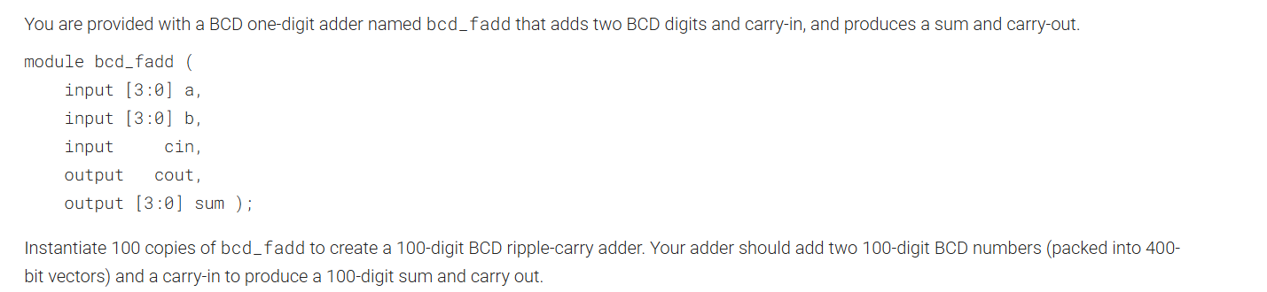

Module Declaration:
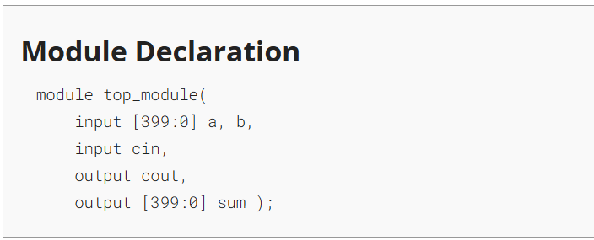

Solution:
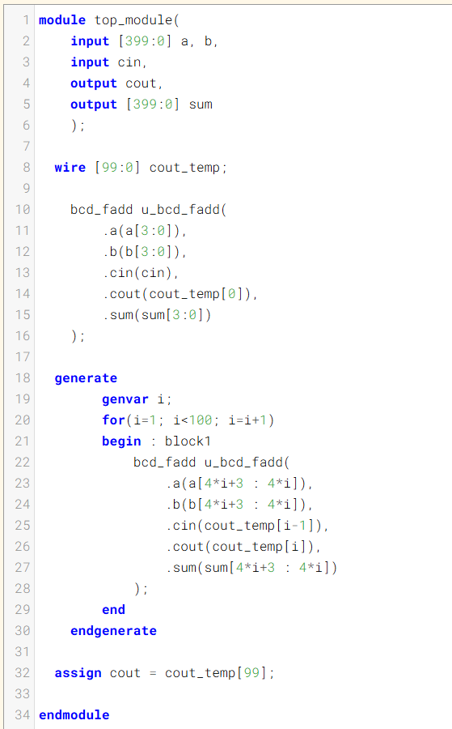

Code:
module top_module(
input [399:0] a, b,
input cin,
output cout,
output [399:0] sum
);

wire [99:0] cout_temp;

bcd_fadd u_bcd_fadd(
.a(a[3:0]),
.b(b[3:0]),
.cin(cin),
.cout(cout_temp[0]),
.sum(sum[3:0])
);

generate
genvar i;
for(i=1; i<100; i=i+1)
begin : block1
bcd_fadd u_bcd_fadd(
.a(a[4*i+3 : 4*i]),
.b(b[4*i+3 : 4*i]),
.cin(cout_temp[i-1]),
.cout(cout_temp[i]),
.sum(sum[4*i+3 : 4*i])
);
end
endgenerate

assign cout = cout_temp[99];

endmodule

DAY:42 exams/m2014_q4h
Problem Statement:
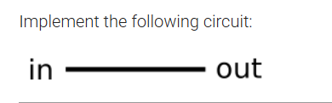
Module Declaration:
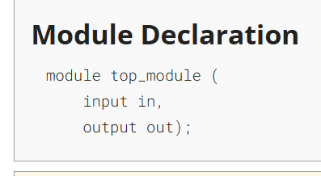
Solution:
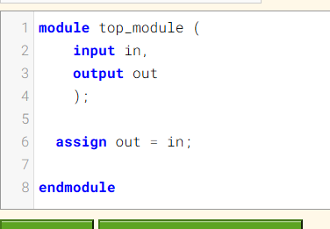

Code:
module top_module (
input in,
output out
);
assign out = in;
endmodule
DAY:43 exams/m2014_q4i
Problem Statement:
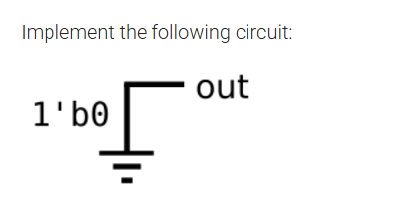
Module Declaration:
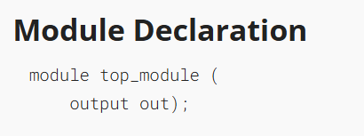

Solution:
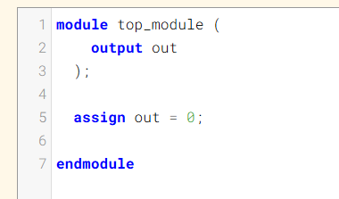
Code:
module top_module (
output out
);
assign out = 0;
endmodule
DAY:44 exams/m2014_q4e
Problem Statement:
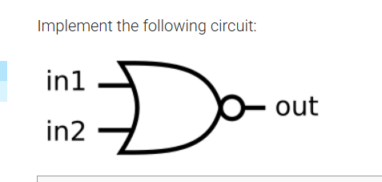

Module Declaration:
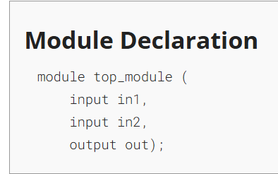
Solution:
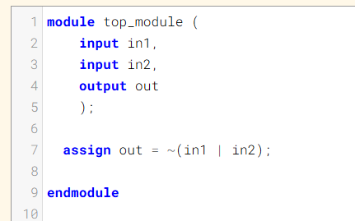
Code:
module top_module (
input in1,
input in2,
output out
);
assign out = ~(in1 | in2);
endmodule
DAY:45 exams/m2014_q4f
Problem Statement:
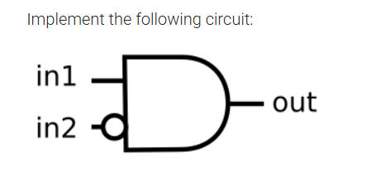
Module Declaration:
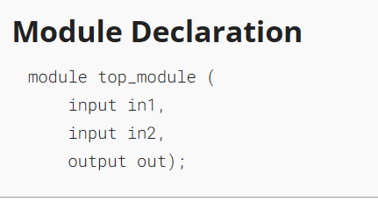
Solution:
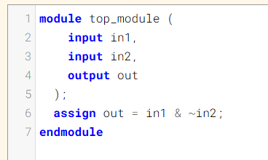
Code:
module top_module (
input in1,
input in2,
output out
);
assign out = in1 & ~in2;
endmodule
DAY:46 exams/m2014_q4g
Problem Statement:
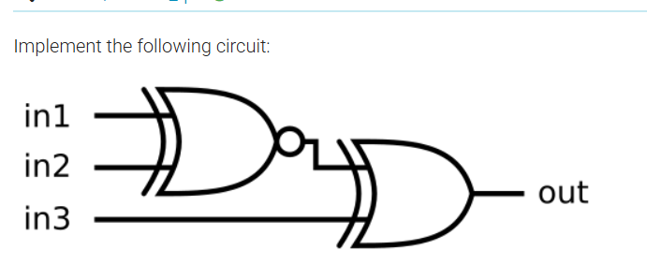Module Declaration:
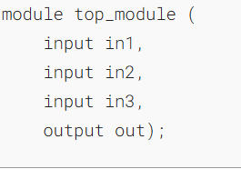
Solution:
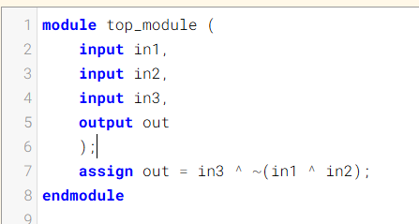
Code:
module top_module (
input in1,
input in2,
input in3,
output out
);
assign out = in3 ^ ~(in1 ^ in2);
endmodule

DAY:47 Gates
Problem Statement:
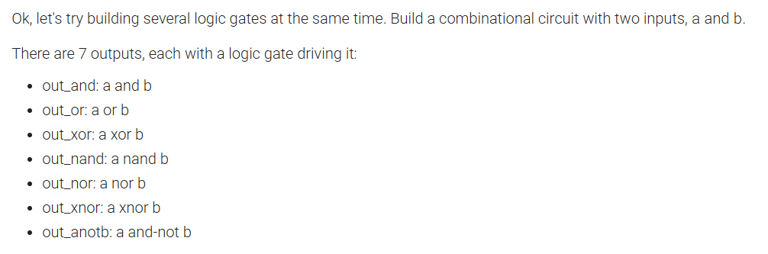
Module Declaration:
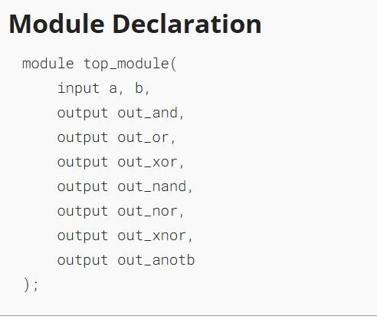

Solution:
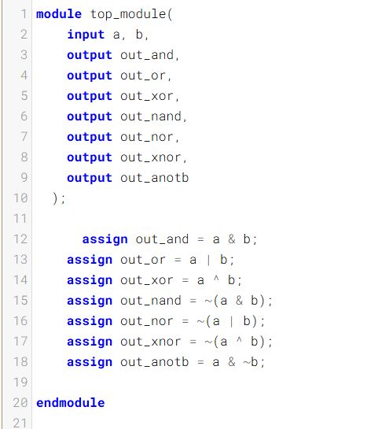
Code:
module top_module(
input a, b,
output out_and,
output out_or,
output out_xor,
output out_nand,
output out_nor,
output out_xnor,
output out_anotb
);

assign out_and = a & b;
assign out_or = a | b;
assign out_xor = a ^ b;
assign out_nand = ~(a & b);
assign out_nor = ~(a | b);
assign out_xnor = ~(a ^ b);
assign out_anotb = a & ~b;

endmodule
Timing Diagram:
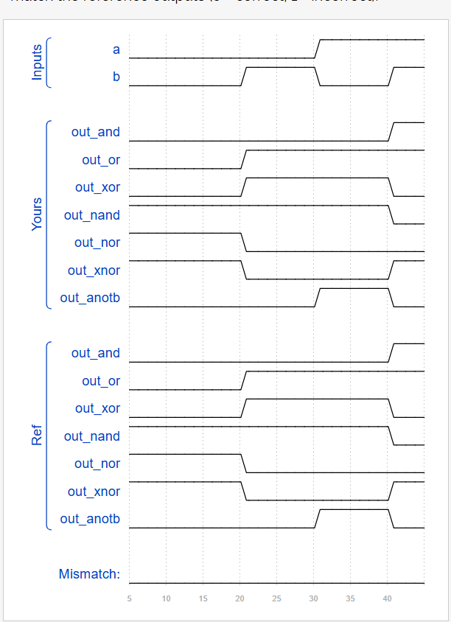

DAY:48 7420
Problem Statement:
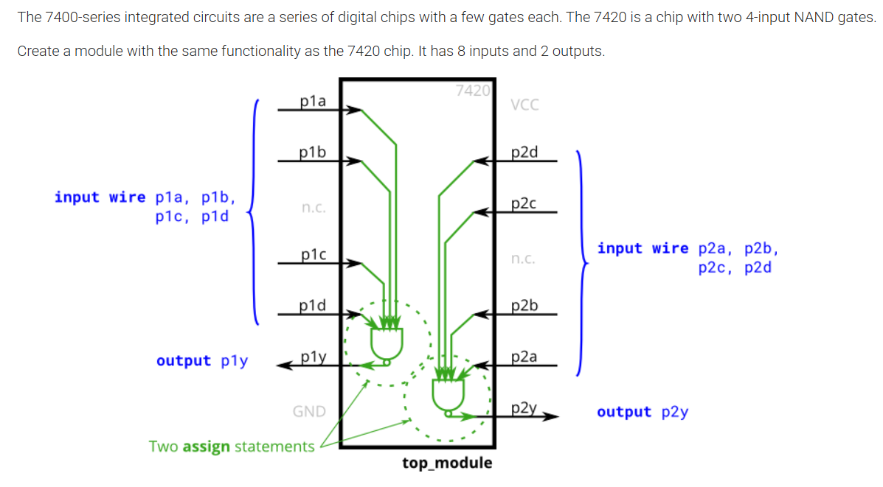
Module Declaration:
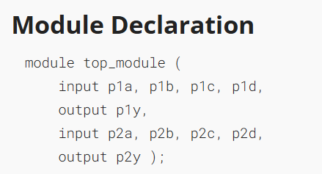
Solution:
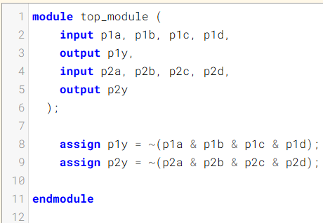
Code:
module top_module (
input p1a, p1b, p1c, p1d,
output p1y,
input p2a, p2b, p2c, p2d,
output p2y
);

assign p1y = ~(p1a & p1b & p1c & p1d);
assign p2y = ~(p2a & p2b & p2c & p2d);

endmodule

Timing Diagram:
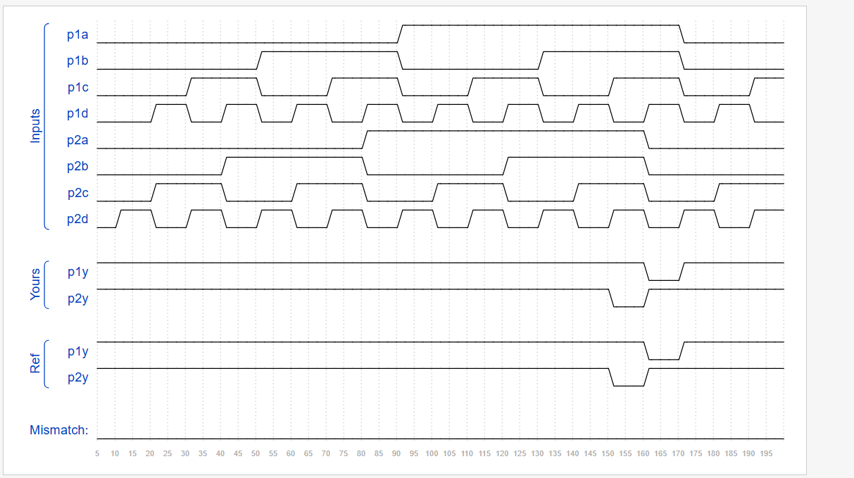
DAY:49 truthtable1
Problem Statement:
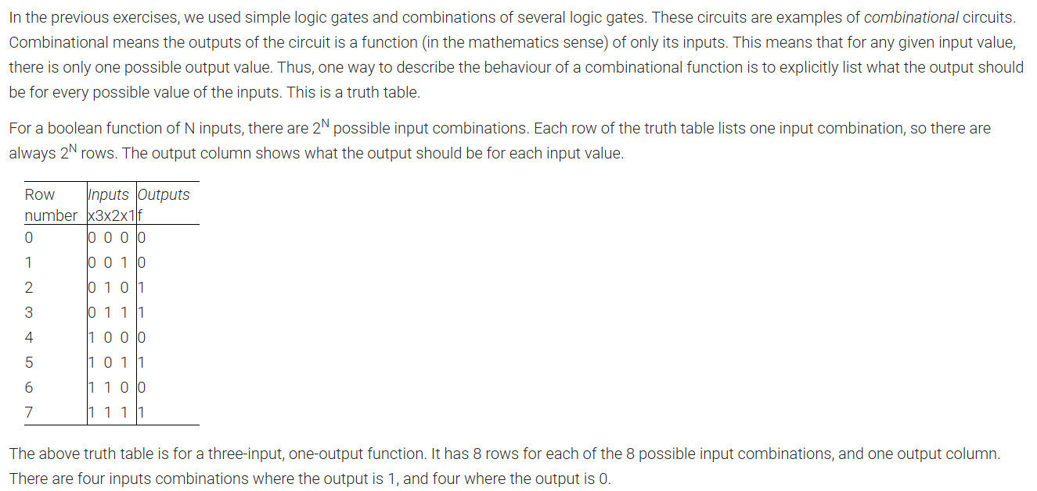

Module Declaration:
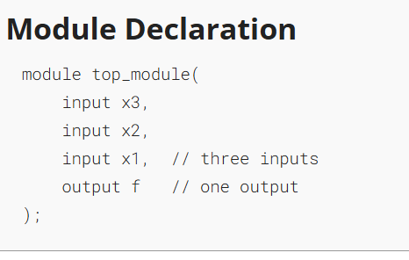

Solution:
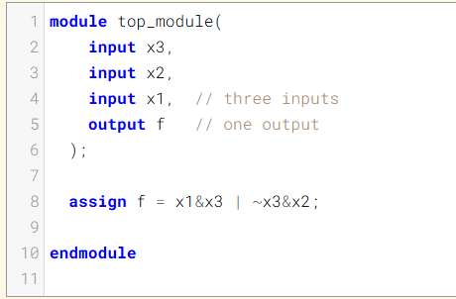
Code:
module top_module(
input x3,
input x2,
input x1, // three inputs
output f // one output
);

assign f = x1&x3 | ~x3&x2;

endmodule
Timing Diagram:
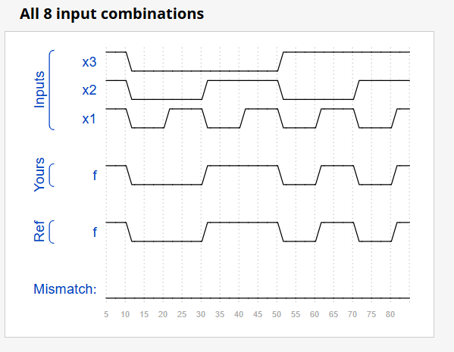

DAY:50 mt2015_eq2
Problem Statement:
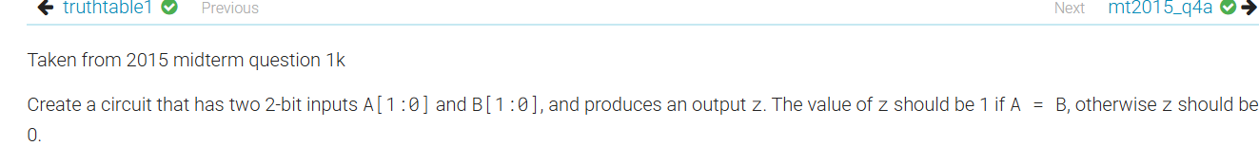
Module Declaration:
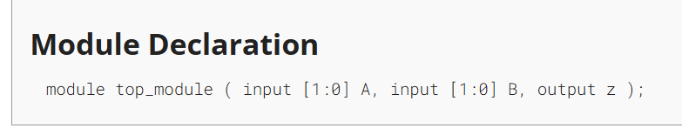
Solution:
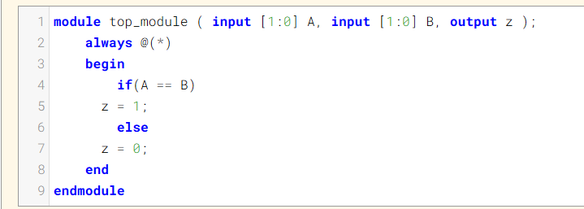

Code:
module top_module ( input [1:0] A, input [1:0] B, output z );
always @(*)
begin
if(A == B)
z = 1;
else
z = 0;
end
endmodule



